PRC Stats Consultants workshop: Exploratory Data Analysis

Shih-Yi Chao

# Exploratory data analysis

Created by: Shih-Yi Chao

Date created: October 18, 2018

Source data: all.dta (user created)

. clear  
  
 . set more off  
  
 . cd "C:\Users\sychao\Dropbox\16_2018Fall\PRC TA\Data for the Talk"  
 C:\Users\sychao\Dropbox\16_2018Fall\PRC TA\Data for the Talk  
  
 . use all.dta, clear

## Explore data

1. **Missing value**

summarizes # of missing values

. mdesc   
  
 Variable | Missing Total Percent Missing  
 ----------------+-----------------------------------------------  
 country | 0 26,282 0.00  
 hp5 | 114 26,282 0.43  
 female | 9 26,282 0.03  
 age | 30 26,282 0.11  
 age2 | 30 26,282 0.11  
 partner | 41 26,282 0.16  
 hedu | 86 26,282 0.33  
 fulltime | 7,818 26,282 29.75  
 employed | 549 26,282 2.09  
 selfemp | 524 26,282 1.99  
 profs | 3,659 26,282 13.92  
 agri | 3,659 26,282 13.92  
 finc_d | 1,449 26,282 5.51  
 pt60 | 230 26,282 0.88  
 urban | 14,954 26,282 56.90  
 familism | 89 26,282 0.34  
 extend | 290 26,282 1.10  
 GDP_p | 0 26,282 0.00  
 TFR | 0 26,282 0.00  
 wlabor | 0 26,282 0.00  
 CPI3 | 0 26,282 0.00  
 GINI | 0 26,282 0.00  
 mc_fam | 0 26,282 0.00  
 mc_ext | 0 26,282 0.00  
 wkhr | 0 26,282 0.00  
 wvs | 0 26,282 0.00  
 abs | 0 26,282 0.00  
 ----------------+-----------------------------------------------

summarizes missing pattern

. misschk hp5 female age partner hedu fulltime employed profs finc_d pt60, gen(miss)  
  
 Variables examined for missing values  
  
 # Variable # Missing % Missing  
 --------------------------------------------  
 1 hp5 114 0.4  
 2 female 9 0.0  
 3 age 30 0.1  
 4 partner 41 0.2  
 5 hedu 86 0.3  
 6 fulltime 7818 29.7  
 7 employed 549 2.1  
 8 profs 3659 13.9  
 9 finc_d 1449 5.5  
 10 pt60 230 0.9  
  
 Warning: this output does not differentiate among extended missing.  
 To generate patterns for extended missing, use extmiss option.  
  
 Missing for |  
 which |  
 variables? | Freq. Percent Cum.  
 -------------+-----------------------------------  
 12__5 _____ | 1 0.00 0.00  
 1_34_ ___90 | 1 0.00 0.01  
 1_3__ 6789_ | 1 0.00 0.01  
 1__45 _____ | 1 0.00 0.02  
 1__4_ ____0 | 1 0.00 0.02  
 1___5 6789_ | 1 0.00 0.02  
 1___5 67___ | 1 0.00 0.03  
 1___5 ___9_ | 1 0.00 0.03  
 1____ 6789_ | 1 0.00 0.03  
 1____ 67_9_ | 1 0.00 0.04  
 1____ 67___ | 2 0.01 0.05  
 1____ 6__90 | 1 0.00 0.05  
 1____ 6__9_ | 1 0.00 0.05  
 1____ 6____ | 7 0.03 0.08  
 1____ __89_ | 6 0.02 0.10  
 1____ __8__ | 14 0.05 0.16  
 1____ ___9_ | 10 0.04 0.19  
 1____ _____ | 63 0.24 0.43  
 _2345 67890 | 1 0.00 0.44  
 _2345 67_9_ | 1 0.00 0.44  
 _23_5 6789_ | 1 0.00 0.45  
 _23_5 __8__ | 1 0.00 0.45  
 _23__ ___9_ | 1 0.00 0.45  
 _2___ _____ | 3 0.01 0.46  
 __3_5 _____ | 1 0.00 0.47  
 __3__ 678_0 | 1 0.00 0.47  
 __3__ 678__ | 1 0.00 0.48  
 __3__ 67_9_ | 1 0.00 0.48  
 __3__ __89_ | 1 0.00 0.48  
 __3__ __8__ | 1 0.00 0.49  
 __3__ ___90 | 1 0.00 0.49  
 __3__ ___9_ | 3 0.01 0.50  
 __3__ _____ | 13 0.05 0.55  
 ___45 __8__ | 1 0.00 0.56  
 ___4_ 678__ | 1 0.00 0.56  
 ___4_ 6____ | 1 0.00 0.56  
 ___4_ __890 | 2 0.01 0.57  
 ___4_ __89_ | 3 0.01 0.58  
 ___4_ __8_0 | 1 0.00 0.59  
 ___4_ __8__ | 3 0.01 0.60  
 ___4_ ___90 | 4 0.02 0.61  
 ___4_ ____0 | 6 0.02 0.64  
 ___4_ _____ | 14 0.05 0.69  
 ____5 67890 | 1 0.00 0.69  
 ____5 678__ | 1 0.00 0.70  
 ____5 67___ | 3 0.01 0.71  
 ____5 6__9_ | 1 0.00 0.71  
 ____5 6____ | 4 0.02 0.73  
 ____5 __890 | 1 0.00 0.73  
 ____5 __89_ | 1 0.00 0.73  
 ____5 __8_0 | 1 0.00 0.74  
 ____5 __8__ | 12 0.05 0.78  
 ____5 ___90 | 2 0.01 0.79  
 ____5 ___9_ | 8 0.03 0.82  
 ____5 ____0 | 5 0.02 0.84  
 ____5 _____ | 35 0.13 0.97  
 _____ 67890 | 1 0.00 0.98  
 _____ 6789_ | 19 0.07 1.05  
 _____ 678_0 | 8 0.03 1.08  
 _____ 678__ | 133 0.51 1.59  
 _____ 67_90 | 2 0.01 1.59  
 _____ 67_9_ | 55 0.21 1.80  
 _____ 67__0 | 4 0.02 1.82  
 _____ 67___ | 308 1.17 2.99  
 _____ 6__90 | 3 0.01 3.00  
 _____ 6__9_ | 259 0.99 3.99  
 _____ 6___0 | 8 0.03 4.02  
 _____ 6____ | 6,984 26.57 30.59  
 _____ __890 | 9 0.03 30.63  
 _____ __89_ | 158 0.60 31.23  
 _____ __8_0 | 46 0.18 31.40  
 _____ __8__ | 3,227 12.28 43.68  
 _____ ___90 | 12 0.05 43.73  
 _____ ___9_ | 874 3.33 47.05  
 _____ ____0 | 108 0.41 47.46  
 _____ _____ | 13,808 52.54 100.00  
 -------------+-----------------------------------  
 Total | 26,282 100.00  
  
 Missing for |  
 how many |  
 variables? | Freq. Percent Cum.  
 ------------+-----------------------------------  
 0 | 13,808 52.54 52.54  
 1 | 11,321 43.08 95.61  
 2 | 866 3.30 98.91  
 3 | 237 0.90 99.81  
 4 | 40 0.15 99.96  
 5 | 4 0.02 99.98  
 6 | 3 0.01 99.99  
 7 | 2 0.01 100.00  
 9 | 1 0.00 100.00  
 ------------+-----------------------------------  
 Total | 26,282 100.00

1. **Examine whether the model violates OLS assumptions**

Research Question: whether family policy is associated with the gap between parents and nonparents, country-level analysis

Method: OLS

Model: happiness gap| family policy index, GDP, TFR, extend family, work hours

**A. Normal Distribution of the Dependent Variable: happiness gap (countinuous)**

. histogram pardiffhp5  
 (bin=4, start=-.14926076, width=.11322314)

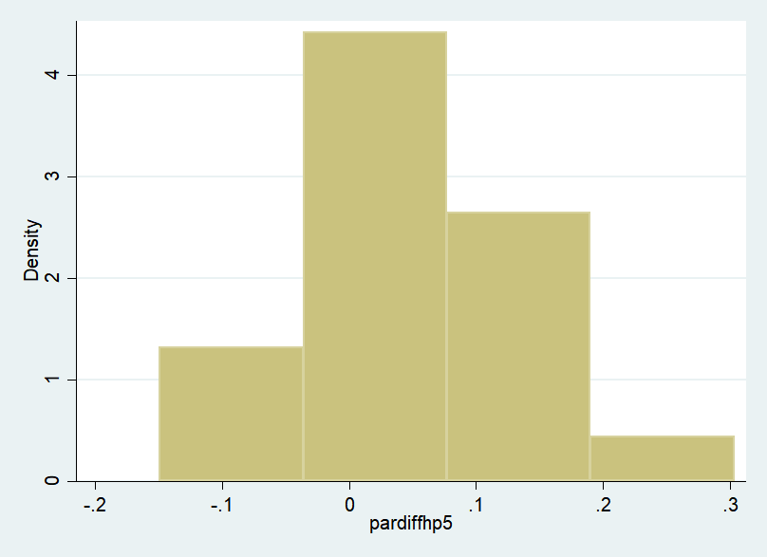

. sum pardiffhp5, d   
  
 pardiffhp5  
 -------------------------------------------------------------  
 Percentiles Smallest  
 1% -.1492608 -.1492608  
 5% -.1361448 -.1230288  
 10% -.1022079 -.081387 Obs 20  
 25% .0202732 -.0151744 Sum of Wgt. 20  
  
 50% .0514926 Mean .0461729  
 Largest Std. Dev. .0972646  
 75% .0821371 .0846527  
 90% .1423922 .1341724 Variance .0094604  
 95% .2271218 .1506119 Skewness .2596614  
 99% .3036318 .3036318 Kurtosis 4.418741

**B. inflential cases: if you remove the cases from anaysis, the estimates have huge changes.**

**B-1 Scatterplots**

. twoway (scatter pardiffhp5 CPI3, mlabel(group) mlabsize(vsmall) mlabposition(12) ti(Parenthood Happiness Gap)) (lfit pardiffhp5 CPI3), ///  
 xtitle(Comprehensive Family Policy Index) ytitle(Predicted Happiness) legend(off)

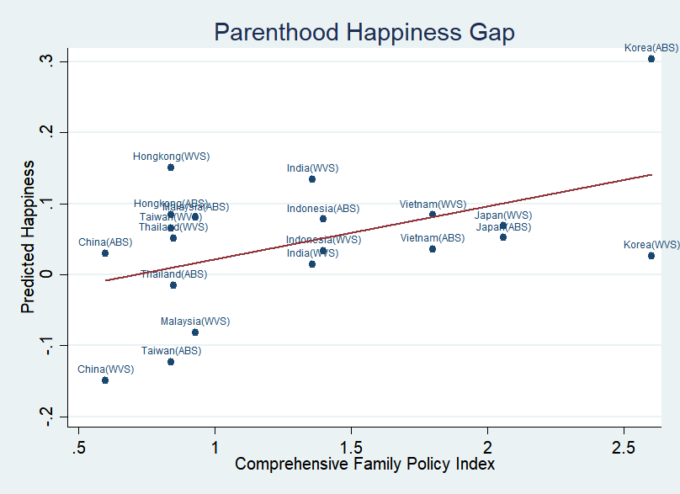

**B-2 Two Tests for the Post estimation**

Cook’s D: threshold 4/n=4/20=0.2 or 1

. reg pardiffhp5 CPI3 GDP_p TFR mc_ext wkhr

Source | SS df MS Number of obs = 20  
 -------------+---------------------------------- F(5, 14) = 1.10  
 Model | .05063412 5 .010126824 Prob > F = 0.4043  
 Residual | .129113621 14 .009222402 R-squared = 0.2817  
 -------------+---------------------------------- Adj R-squared = 0.0252  
 Total | .179747741 19 .009460407 Root MSE = .09603  
  
 ------------------------------------------------------------------------------  
 pardiffhp5 | Coef. Std. Err. t P>|t| [95% Conf. Interval]  
 -------------+----------------------------------------------------------------  
 CPI3 | .07767 .0396367 1.96 0.070 -.0073422 .1626822  
 GDP_p | 2.69e-06 4.03e-06 0.67 0.515 -5.95e-06 .0000113  
 TFR | .0316952 .0614501 0.52 0.614 -.1001022 .1634927  
 mc_ext | -.001246 .0052744 -0.24 0.817 -.0125585 .0100666  
 wkhr | .007301 .0101707 0.72 0.485 -.014513 .0291151  
 _cons | -.4426499 .5959823 -0.74 0.470 -1.720905 .8356051  
 ------------------------------------------------------------------------------  
  
  
 . predict dfit,dfits  
  
 . predict d, cooksd  
  
 . list country data d if abs(d)>.2  
  
 +----------------------------+  
 | country data d |  
 |----------------------------|  
 3. | Korea WVS .297501 |  
 8. | Malaysia WVS .2901316 |  
 13. | Korea ABS .369459 |  
 +----------------------------+

DFBETAS: threshold 2/sqrt(n) or 1

. dfbeta  
 _dfbeta_1: dfbeta(CPI3)  
 _dfbeta_2: dfbeta(GDP_p)  
 _dfbeta_3: dfbeta(TFR)  
 _dfbeta_4: dfbeta(mc_ext)  
 _dfbeta_5: dfbeta(wkhr)  
  
 . list country data _dfbeta_1 if abs(_dfbeta_1)>.4472136  
  
 +----------------------------+  
 | country data _dfbeta_1 |  
 |----------------------------|  
 3. | Korea WVS -1.156612 |  
 13. | Korea ABS 1.333305 |  
 +----------------------------+

**C. Multicollinearity: the independent variables have no perfect correlations**

vif (the variance inflation factor = 2.5)

. vif  
  
 Variable | VIF 1/VIF   
 -------------+----------------------  
 GDP_p | 4.87 0.205394  
 wkhr | 3.19 0.313701  
 TFR | 3.17 0.315393  
 mc_ext | 1.69 0.590375  
 CPI3 | 1.29 0.777307  
 -------------+----------------------  
 Mean VIF | 2.84

There are three situations in which a high VIF is not a problem

1. The variables with high VIFs are control variables and the variables of interest do not have high VIFs

2. The high VIFs are caused by the inclusion of powers or products of other variables

3. The variables with high VIFs are indicators (dummy) variables that represent a categorical variable with three or more categories

**D. Heteroskedasticity: the error variance is not constant for all observations**

. rvfplot

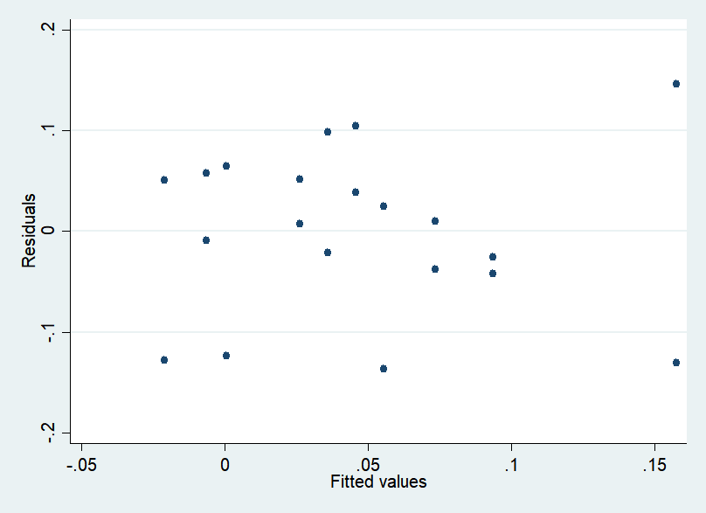

. estat hettest  
  
 Breusch-Pagan / Cook-Weisberg test for heteroskedasticity   
 Ho: Constant variance  
 Variables: fitted values of pardiffhp5  
  
 chi2(1) = 1.07  
 Prob > chi2 = 0.3016

**E. Omitted Variable: endogeneity**

. ovtest  
  
 Ramsey RESET test using powers of the fitted values of pardiffhp5  
 Ho: model has no omitted variables  
 F(3, 11) = 0.86  
 Prob > F = 0.4904

**F. Specification Error**

. scatter pardiffhp5 CPI3 ||lowess pardiffhp5 CPI3

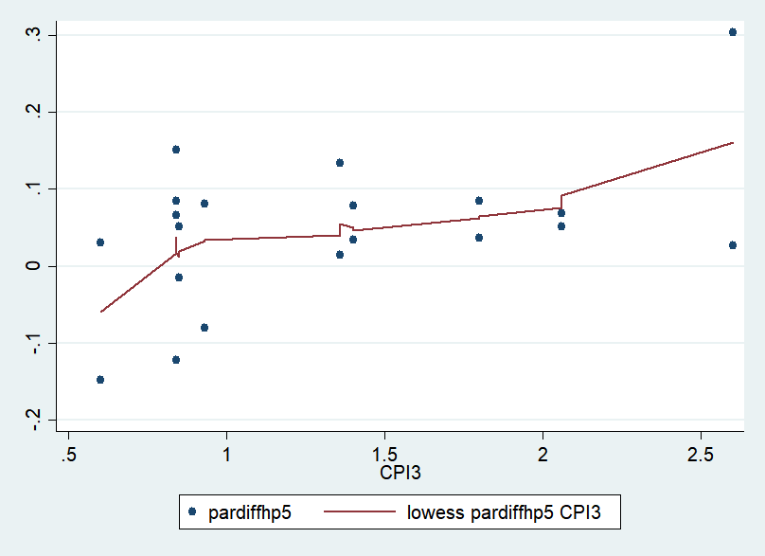

. acprplot CPI3, lowess

